PROJECT DOCUMENTATION

Enforcing Mandatory Fields Using UI Policies and Migrating Changes with Update Sets

Team Members
Santhiya A
Nithya Sri S
Philomina L
Vidhya Vikashini

Project report:
1. INTRODUCTION
2. IDEATHON PHASE
3. REQUIREMENT ANALYSIS
4. PROJECT DESIGN PHASE
5. PROJECT PLANNING PHASE
6. PROJECT DEVELOPMENT PHASE
7. ADVANTAGES & DISADVANTAGES
8. PROJECT DOCUMENTATION
9. CONCLUSION

Introduction
In modern enterprise applications, forms are widely used to collect and manage data from users. These forms may contain several fields such as user details, request information, incident descriptions, and other important data. Ensuring that all required information is entered correctly is very important for maintaining accurate records in the system. However, many times users may skip some fields while submitting the form, which can lead to incomplete or incorrect data being stored in the database.
To solve this problem, systems use validation mechanisms that ensure users enter all the necessary information before submitting a form. One effective way to implement this validation is through UI Policies. UI Policies allow administrators and developers to control the behavior of fields on a form dynamically. Using UI Policies, fields can be made mandatory, read-only, or visible based on specific conditions. This helps maintain data accuracy and ensures that users provide all required information.
Another important aspect of system development is managing and transferring configuration changes between different environments. In most organizations, development is done in a development instance, and once the changes are verified, they must be moved to testing or production instances. This process requires a reliable way to track and migrate configuration changes.
To achieve this, Update Sets are used. Update Sets capture all the configuration changes made during development. These captured changes can then be moved from one instance to another, ensuring that the system configuration remains consistent across different environments.
This project focuses on implementing mandatory field validation using UI Policies and migrating the configured changes using Update Sets. By using these features, the system ensures proper data validation and efficient configuration management. The project demonstrates how UI Policies improve form usability and how Update Sets simplify the migration of system changes between different environments.
Overall, the implementation of UI Policies and Update Sets helps organizations maintain data accuracy, system consistency, and efficient development workflows.

2. IDEATION PHASE
The Ideation Phase is the stage where ideas are generated, discussed, and evaluated in order to find the best possible solution for a problem. In this phase, the project team focuses on understanding the problem clearly and exploring different approaches that can be used to solve it. The goal of this phase is to identify an effective and practical solution that can improve the existing system.
In this project, the team identified that many systems allow users to submit forms without filling in all the required fields. This leads to incomplete data, incorrect records, and difficulties in managing information. Therefore, the team decided to explore methods that could ensure proper validation of form fields.

Brainstorming
During the brainstorming session, all team members discussed various possible solutions to improve form validation and configuration management. The following ideas were considered:
• Implementing manual validation checks in forms
• Using scripts to validate input fields
• Applying UI Policies to control field behavior
• Creating validation rules for mandatory fields
• Using Update Sets for tracking configuration changes
After analyzing these options, the team realized that UI Policies provide a simple and efficient method to enforce field validation without requiring complex programming.

Idea Generation
Based on the brainstorming discussion, the idea generated for the project was to implement UI Policies to enforce mandatory fields in forms. This ensures that users cannot submit forms unless they provide the required information.
Additionally, the team decided to implement Update Sets to track and migrate configuration changes between different instances. This allows developers to safely move system configurations from the development environment to other environments such as testing or production.

Idea Prioritization
After generating different ideas, the team prioritized the solutions based on the following factors:
• Ease of implementation
• System efficiency
• Maintainability
• Scalability
• Practical usage in real-world applications
Among all the options, UI Policies and Update Sets were selected because they are widely used in enterprise platforms and provide an effective solution for validation and configuration migration.

3. REQUIREMENT ANALYSIS
Requirement Analysis is the process of identifying and understanding the needs of the system before development. It helps define what the system should do and ensures that the project meets user requirements.
In this project, the main requirement is to enforce mandatory fields using UI Policies and migrate configuration changes using Update Sets. The system must ensure that users cannot submit a form without filling the required fields and that configuration changes can be transferred safely between different instances.

User Stories
- As a user, I want the system to ensure all required fields are filled before submitting the form.
- As an administrator, I want to configure UI Policies to control field behavior.
- As a developer, I want to capture and migrate configuration changes using Update Sets.

Functional Requirements
- The system should allow creation of UI Policies.
- The system should make specific fields mandatory.
- The system should prevent form submission if mandatory fields are empty.
- The system should capture configuration changes using Update Sets.
- The system should allow migration of Update Sets between instances.

Non-Functional Requirements
- The system should be reliable and easy to use.
- The system should ensure data accuracy.
- The system should maintain system consistency during migration.

Technology Stack
- Platform: ServiceNow
- Feature Used: UI Policies
- Migration Tool: Update Sets

Data Flow Diagram (DFD)
A Data Flow Diagram (DFD) shows how data moves through the system. It explains how the user enters data, how the system checks mandatory fields using UI Policies, and how the data is stored in the database.
In this project, the DFD represents the flow of information from the user input to validation and final storage.
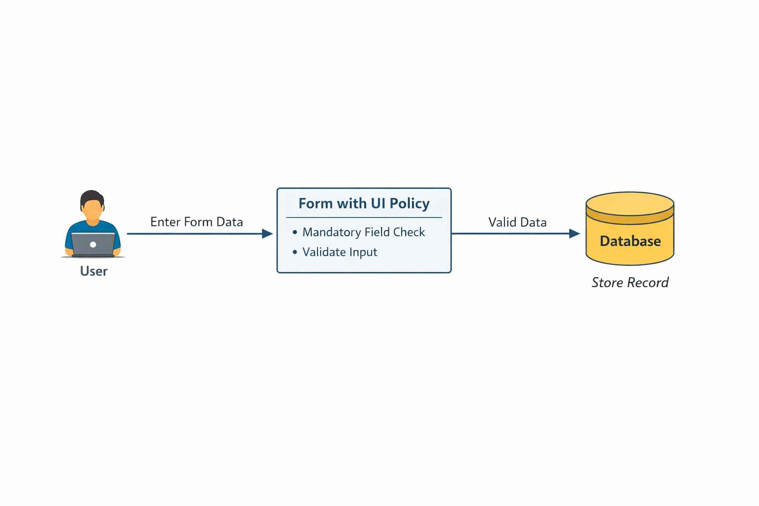

4. PROJECT DESIGN PHASE
The Project Design Phase focuses on planning how the system will be developed and how the components will work together. In this phase, the structure of the system is designed to ensure that it meets the project requirements effectively.
For this project, the design mainly focuses on implementing UI Policies to enforce mandatory fields and using Update Sets to migrate configuration changes between different instances.

Problem – Solution Fit
The main problem identified is that users may submit forms without entering all the required information, which leads to incomplete records in the system. This affects data accuracy and system reliability.
To solve this problem, UI Policies are used to make important fields mandatory. When a UI Policy is applied to a form, it ensures that users must fill the required fields before submitting the form.
Another challenge is moving configuration changes from one system instance to another. This problem is solved using Update Sets, which capture all configuration changes made during development and allow them to be migrated safely to another environment.
Thus, UI Policies ensure data validation, and Update Sets ensure efficient configuration migration.

Proposed Solution
The proposed solution is to configure UI Policies in the system to control the behavior of form fields. These UI Policies will make specific fields mandatory based on conditions. If a user tries to submit the form without filling the mandatory fields, the system will display a validation message.
At the same time, all configuration changes related to UI Policies will be captured using Update Sets. These Update Sets will then be exported and imported into another instance to replicate the configuration.
This solution helps maintain data consistency, proper validation, and efficient system configuration management.

System Architecture
The system architecture includes the following components:
• User Interface – The form where users enter data.
• UI Policy Engine – Controls the behavior of form fields.
• Application Server – Processes user requests and validations.
• Database – Stores the validated records.
• Update Set Repository – Stores configuration changes for migration.
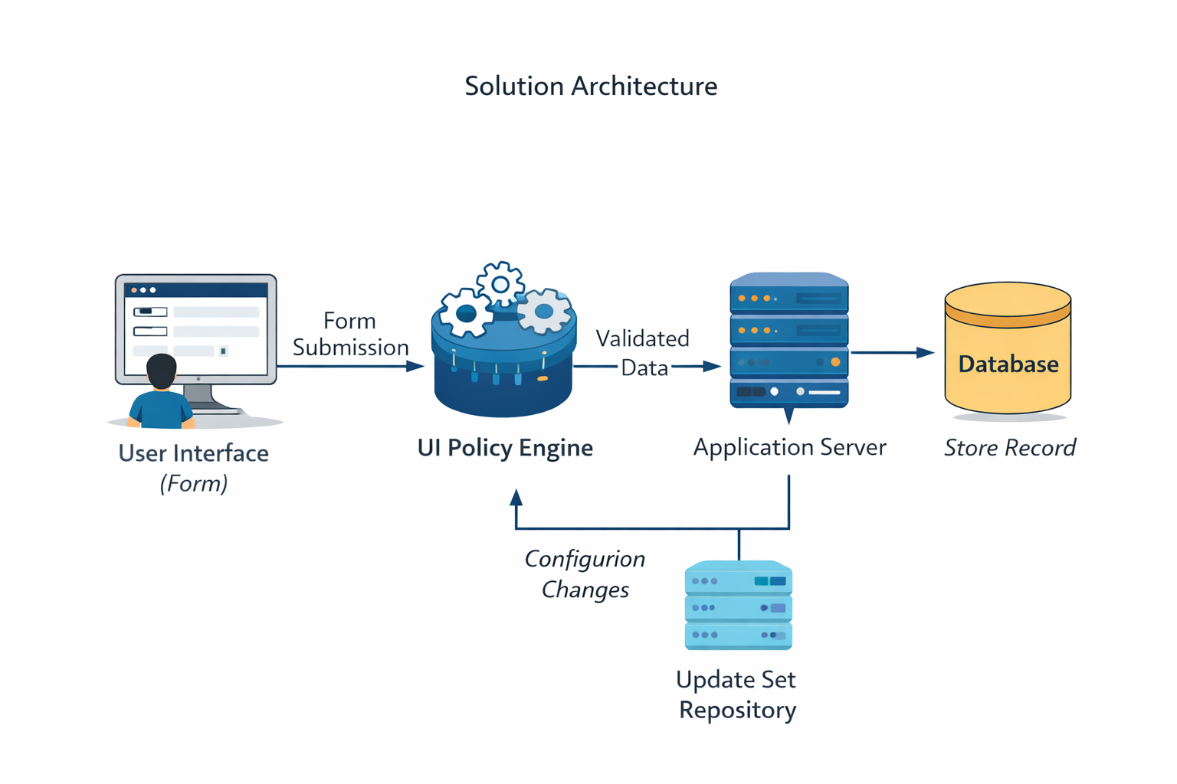

5. PROJECT PLANNING PHASE
The Project Planning Phase involves organizing and scheduling the activities required to complete the project successfully. In this phase, the team decides how the project will be carried out, what tasks need to be completed, and how responsibilities will be divided among the team members.
For this project, the planning phase focused on implementing UI Policies to enforce mandatory fields and using Update Sets to migrate configuration changes between instances.

Project Planning Steps
1. Requirement Identification
The first step was to identify the project requirements. The team analyzed how mandatory fields can be enforced in forms and how configuration changes can be migrated using update sets.
2. Task Allocation
The project tasks were divided among the team members. Each member was responsible for specific activities such as UI Policy configuration, testing, documentation, and update set migration.
3. System Setup
The development environment was prepared using a ServiceNow instance where UI Policies were created and tested.
4. Implementation Planning
The team planned the steps required to implement the solution, including creating UI Policies, validating mandatory fields, capturing changes using update sets, and migrating them to another instance.
5. Testing Plan
A testing strategy was prepared to ensure that the UI Policies correctly enforce mandatory fields and that Update Sets migrate changes successfully.
6. Documentation Planning
The final step was to plan the preparation of project documentation, including diagrams, screenshots, and explanations of the implementation process.
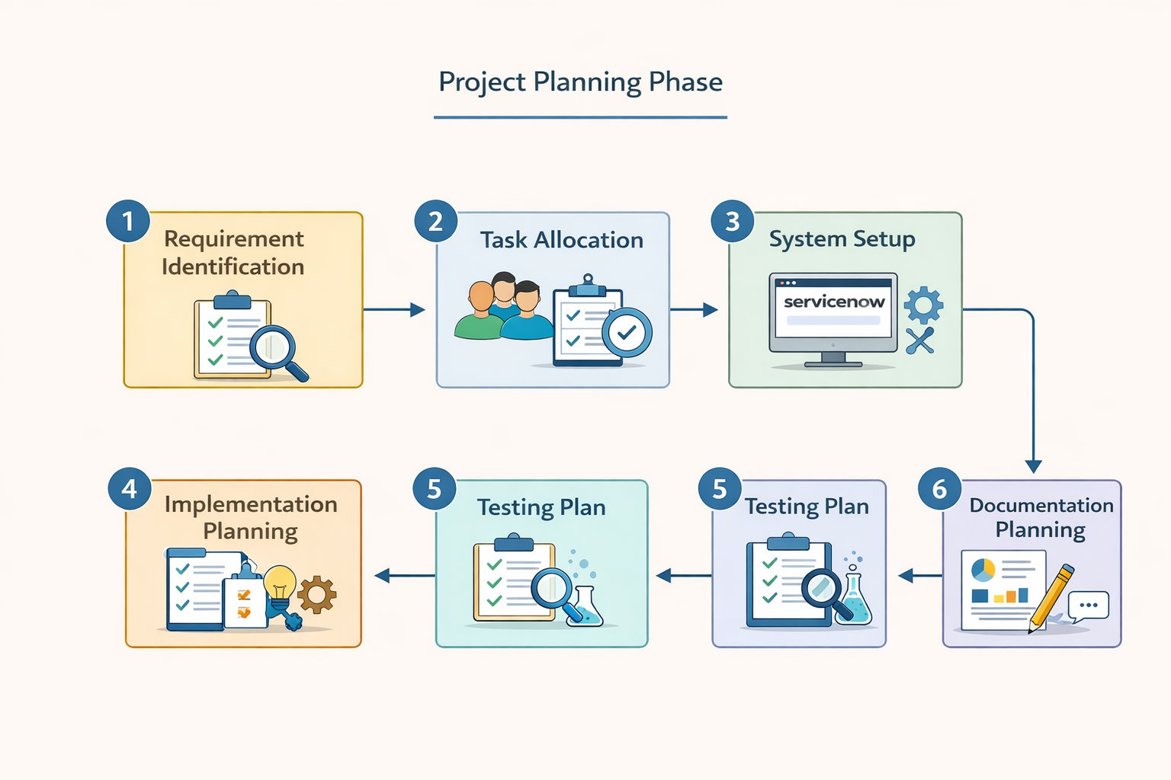

6. PROJECT DEVELOPMENT PHASE
The Project Development Phase is the stage where the actual implementation of the project takes place. In this phase, the planned design and requirements are converted into a working system. The development process includes configuring UI Policies, enforcing mandatory fields, creating Update Sets, and migrating the configuration changes between instances.
In this project, the development was carried out using the ServiceNow platform, where UI Policies were created to control form field behavior and Update Sets were used to track and migrate configuration changes.

Implementation Steps

1. UI Policy Configuration
In this step, a UI Policy was created on the required table in ServiceNow. The UI Policy conditions were defined to control when the policy should be applied. The fields that needed validation were configured to become mandatory when the UI Policy condition was satisfied.

2. Mandatory Field Validation
After configuring the UI Policy, the form was tested to ensure that the required fields became mandatory. If a user attempted to submit the form without filling the mandatory fields, the system displayed a warning message and prevented form submission.

3. Update Set Creation
An Update Set was created to capture all configuration changes made during development. Whenever a UI Policy or related configuration was created or modified, the changes were automatically recorded in the active Update Set.

4. Update Set Migration
Once development was completed, the Update Set was exported from the development instance and imported into another instance. After importing, the Update Set was committed so that the configuration changes were applied in the target environment.

5. Testing and Validation
Finally, the system was tested to ensure that the UI Policies worked correctly and that the Update Set migration successfully transferred all configurations. The testing confirmed that mandatory fields were enforced properly and that configuration changes were migrated without errors

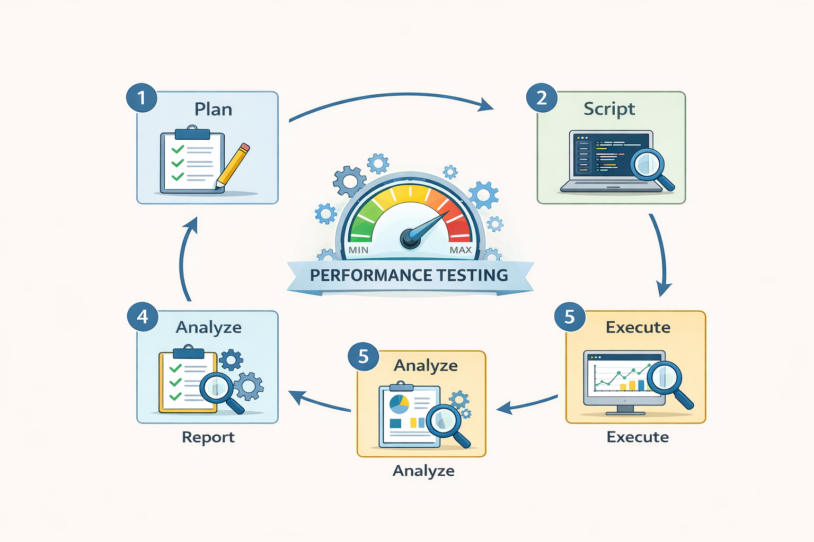

7. ADVANTAGES AND DISADVANTAGES

Advantages
1. Improves Data Accuracy
UI Policies ensure that mandatory fields are filled before submitting the form, which helps maintain accurate and complete data in the system.
2. Better User Guidance
Mandatory field indicators help users understand which information is required, making the form easier to use.
3. Easy Configuration
UI Policies can be configured easily without complex coding, making them simple for administrators to manage.
4. Efficient Change Management
Update Sets help capture and track configuration changes, making it easier to manage system updates.
5. Safe Migration of Changes
Update Sets allow developers to migrate configurations from one instance to another without losing data or settings.

Disadvantages
1. Configuration Errors
If UI Policies are configured incorrectly, they may affect the form behavior and cause issues for users.
2. Dependency on Proper Update Set Management
If Update Sets are not managed properly, it may lead to missing or conflicting configurations during migration.
3. Limited Control Compared to Scripts
UI Policies are suitable for simple validations, but complex validations may require scripting.
4. Additional Testing Required
Every UI Policy and Update Set must be tested carefully to ensure proper system functionality.
Screen layouts :

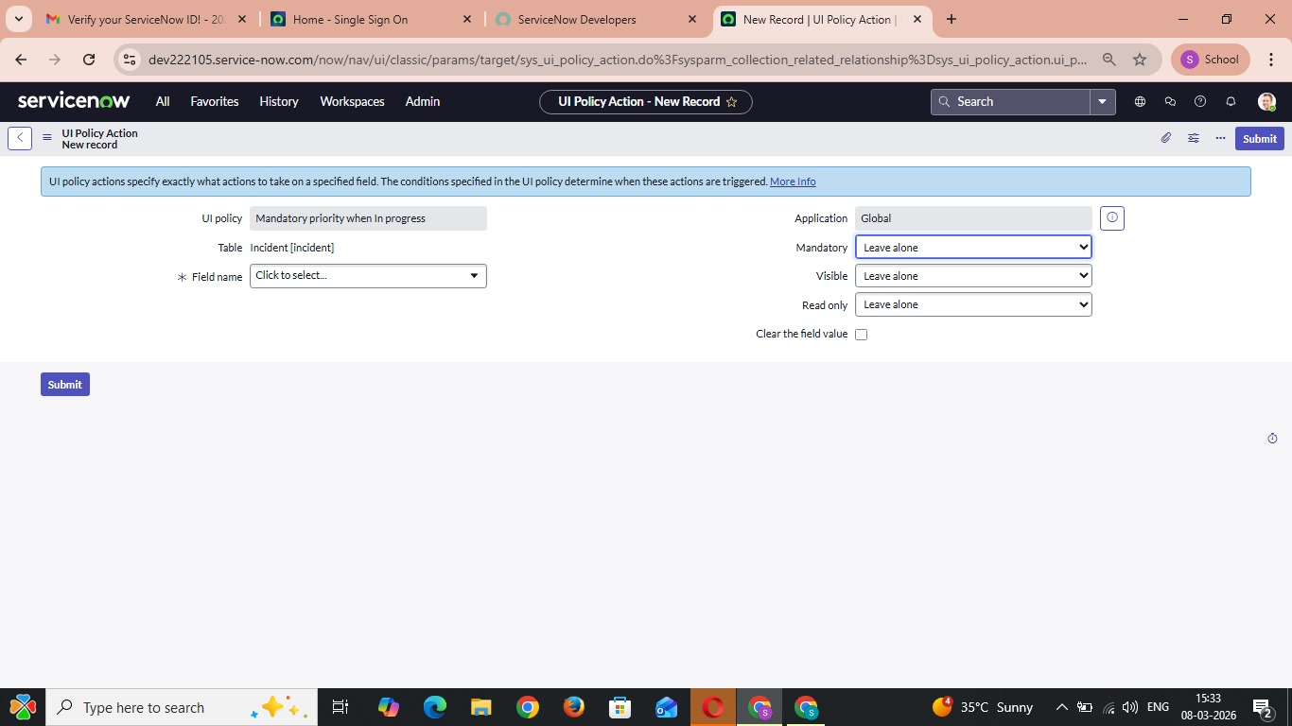

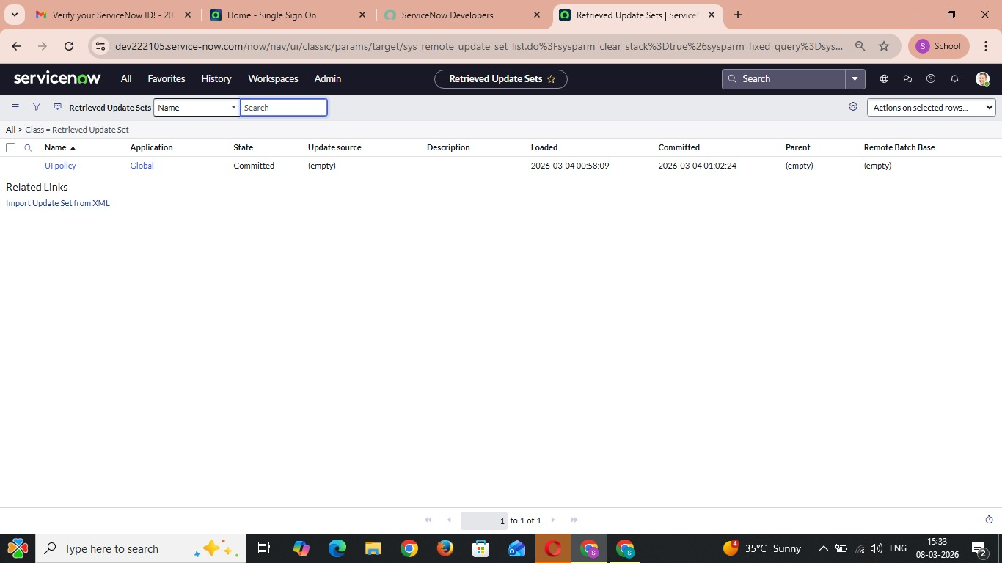
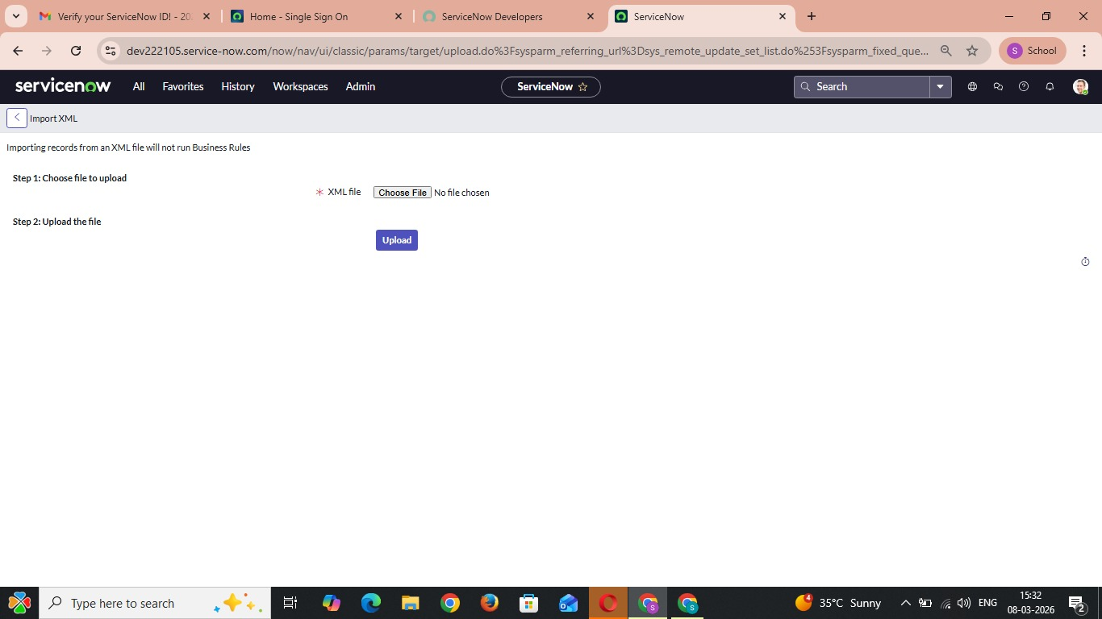

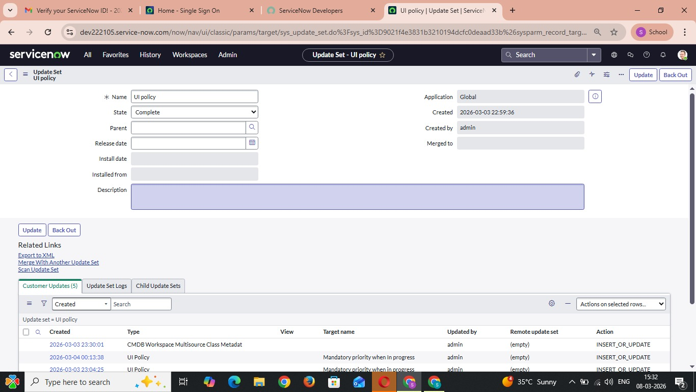

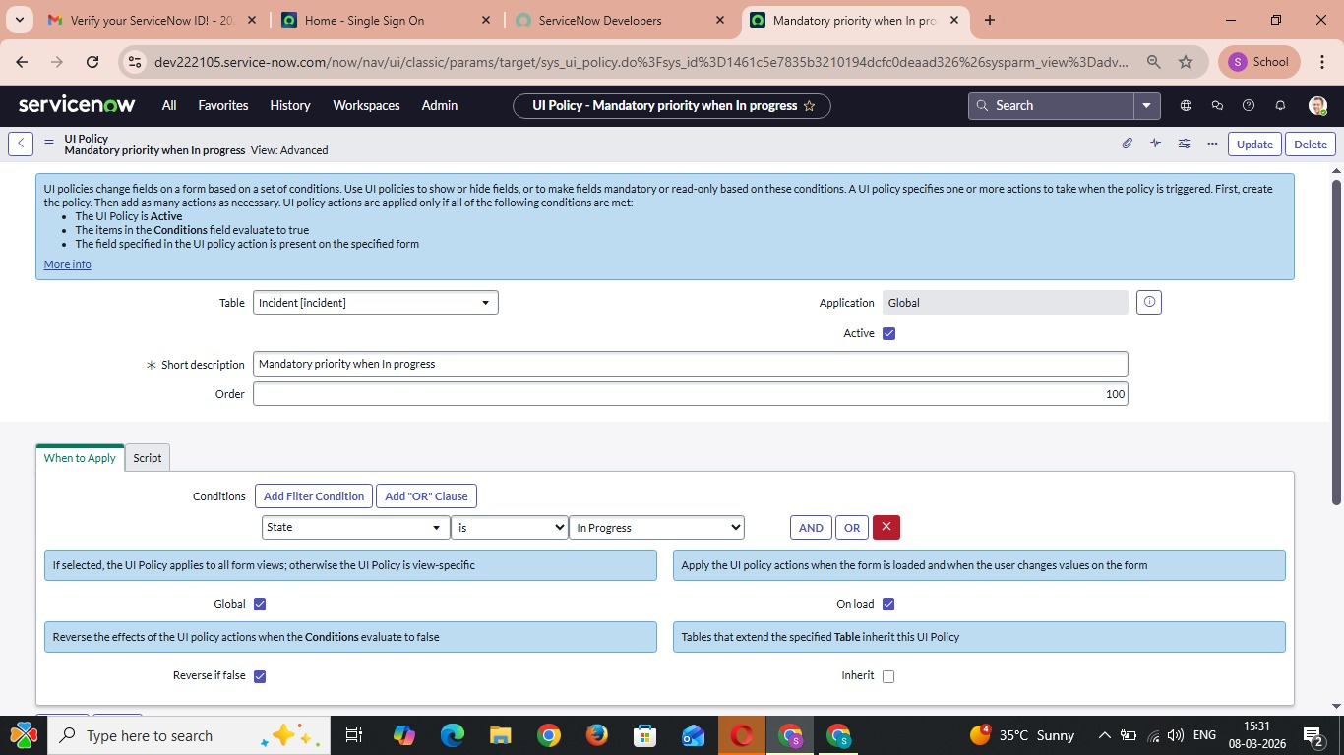

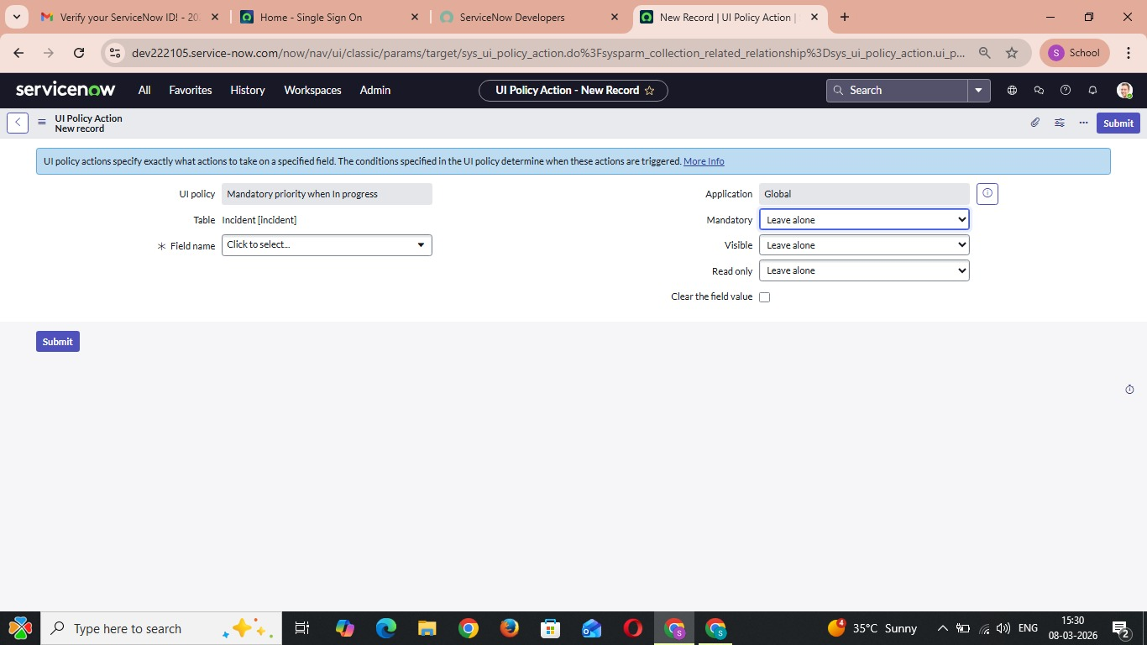

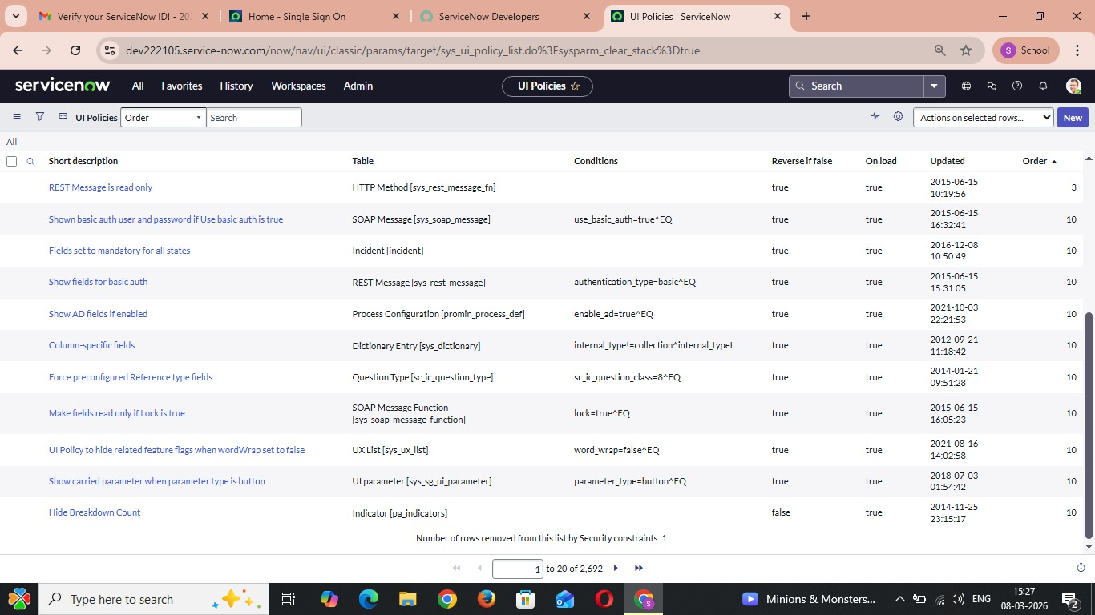

Conclusion :
The project “Enforcing Mandatory Fields Using UI Policies and Migrating Changes with Update Sets” demonstrates how form validation and configuration management can be effectively implemented in the ServiceNow platform.
By using UI Policies, the system ensures that important fields in forms are marked as mandatory. This prevents users from submitting incomplete forms and helps maintain accurate and reliable data in the system. UI Policies also improve the user experience by clearly indicating which fields must be filled before submitting the form.
The project also shows how Update Sets can be used to capture and migrate configuration changes between different instances. This makes it easier for developers to move system configurations from the development environment to testing or production environments in a safe and organized manner.
Through the successful implementation of UI Policies and Update Sets, the project improves data accuracy, system consistency, and efficient configuration management. It also demonstrates how these features simplify system administration and reduce errors during development and deployment.
Overall, this project highlights the importance of proper validation and configuration management in enterprise systems and provides a practical solution using the tools available in the ServiceNow platform.

